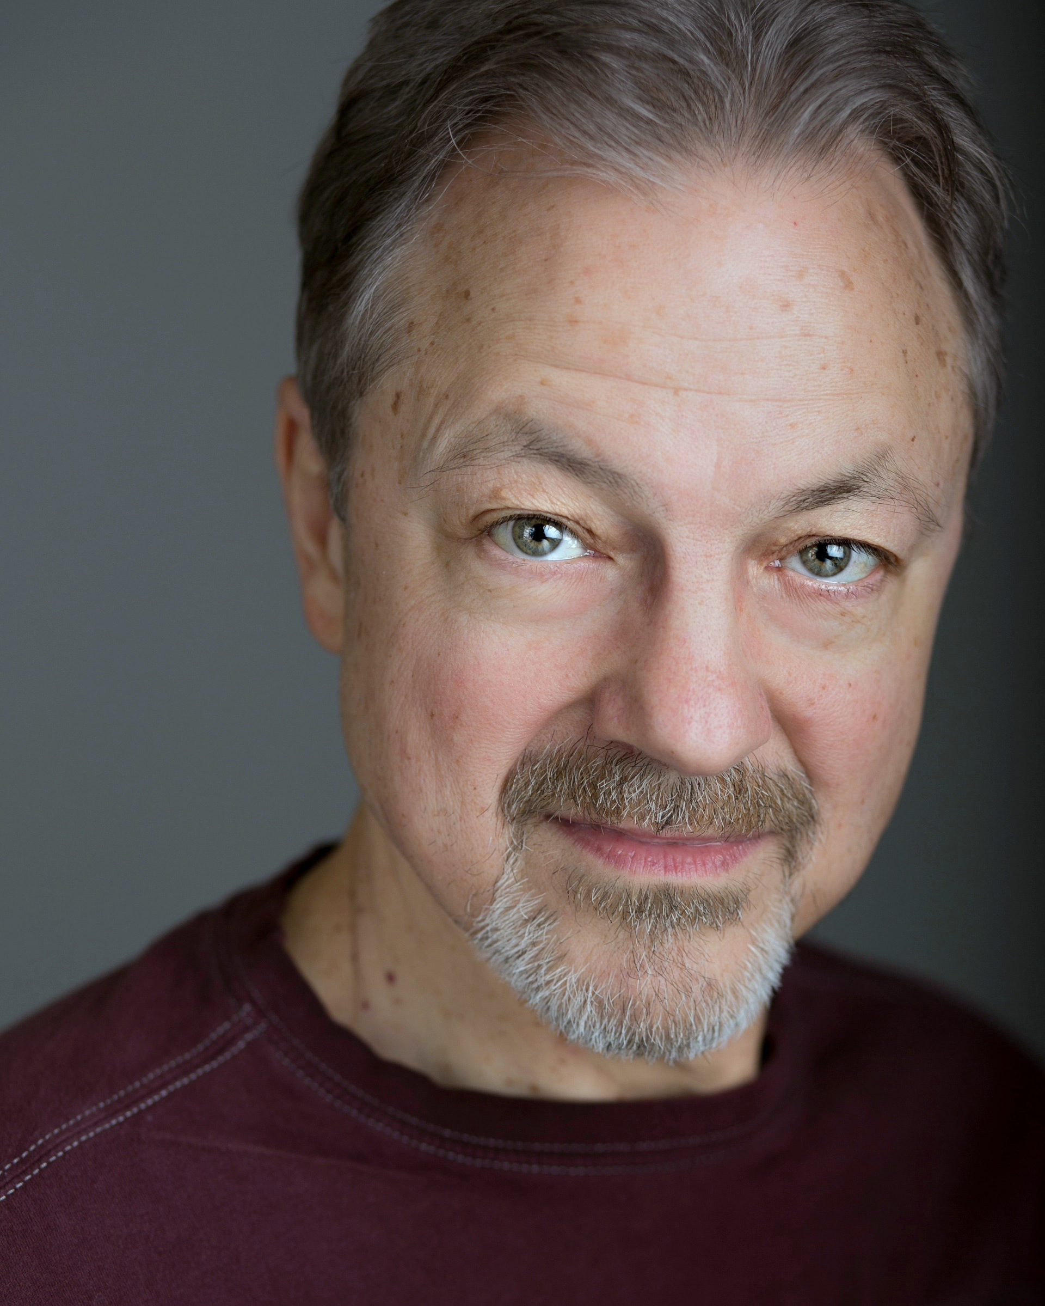––

Edward Christian edwardchristian.com
202-429-4785
Actors@capitaltalentagency.com

AEA
Ht: 5’8” Wt: 165 lbs

Theater

Well | Head Nurse, Howard, D | 1st Stage/Dir. Michael Bloom
Diary of Anne Frank | Kraler, Nazi | Olney Theatre/Dir. Derek Goldman
Falling Out Of Time | Centaur | Theater J/Dir. Derek Goldman
The Sisters Rosensweig | Nick Pym | Theater J/Dir. Kasi Campbell
Passion Play | Carpenter/Ensemble | Forum Theatre/Dir.Michael Dove
The Love of the Nightingale | King Pandion, Male chorus | Constellation/Dir.Allison Arkell Stockman
carried away on the crest of a wave | Crumb, Rick | Hub Theatre/Dir.Helen Murray Pafumi
Agnes Under the Big Top | Shipkov | Forum Theatre/Dir. Michael Dove
The Hampton Years | President Bridgman/Art Critic | Theater J/Dir.Shirley Serotsky
Henry V | King of France, Grey, Salisbury | Folger Theatre/Dir. Robert Richmond
Taming of the Shrew | Pedant, Bartencio | Folger Theatre/Dir. Aaron Posner
The Language Archive | Resten | Forum Theatre/Dir. Jessica Burgess
Much Ado About Nothing | Leonato | Perseverance Theatre/Dir. Eleanor Holdridge
Twelfth Night | Sir Toby Belch | Perseverance Theatre/Dir. PJ Paparelli
The Laramie Project | Moises, Dennis Shepherd | Perseverance Theatre/Dir. Leigh Fondakowski
How I Learned to Drive | Uncle Peck | Perseverance Theatre/Dir. Peter DuBois
The Tempest | Caliban | Perseverance Theatre/Dir. Molly Smith
This Wonderful Life | One Man Show (30+ characters) | Perseverance Theatre/Dir. Tim Hyland
Blithe Spirit | Charles | Perseverance Theatre/Dir. Anita Maynard-Losh
The Crucible | Reverend Parris | Perseverance Theatre/Dir. Eleanor Holdridge
Doubt | Father Flynn | Perseverance Theatre/Dir. Flordelino Lagundino
The Rocky Horror Show | Eddie, Doctor Scott | Perseverance Theatre/Dir. Anita Maynard-Losh
A Streetcar Named Desire | Mitch | Perseverance Theatre/Dir. Molly Smith
The People’s Temple | Phil Tracy, Congressman Ryan | Perseverance Theatre/Dir. Leigh Fondakowski
Hedda Gabler | Lovborg | Perseverance Theatre/Dir. Molly Smith
Equus | Frank Strang | Perseverance Theatre/Dir. PJ Paparelli
Macbeth | Banquo | Perseverance Theatre/Dir. Molly Smith
A Midsummer Night’s Dream | Peter Quince | Perseverance Theatre/Dir. PJ Paparelli
The Cherry Orchard | Peter Trofimov | Perseverance Theatre/Dir. Molly Smith
Hamlet, Prince of Denmark | Player King, Gravedigger | Perseverance Theatre/Dir. PJ Paparelli
Man in the Flying Lawn Chair | Walter | Perseverance Theatre/Dir. Peter Dubois
The Oedipus Cycle | Kreon | Perseverance Theatre/Dir. Molly Smith
The Waiting Room | Doctor Doug | Perseverance Theatre/Dir. Anita Maynard-Losh
Wild Nights with Emily | Austin Dickinson | Perseverance Theatre/Dir. Peter DuBois

Screen

American Milkshake | principal | A film by David Andalman, (premiered at Sundance 2013)
The Men Who Build America | principal | History Channel
For the rights of All: Ending Jim Crow in Alaska | supporting | PBS  Dir. Jeffry Silverman

Training/Special Skills

English dialects: RP, Cockney, Scottish, Boston, Texas. Stage Combat: hand-to-hand, broadsword, rapier & dagger. Spanish.

